**MACHINE PROBLEM NO. 4**

Screenshots and Proof of Testing

**CODE:**

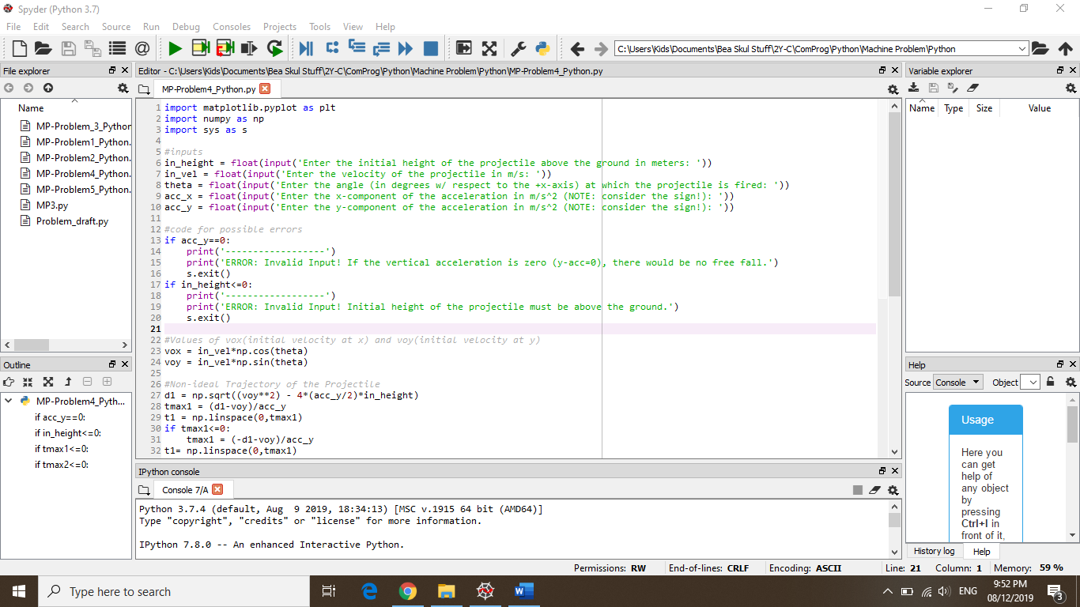

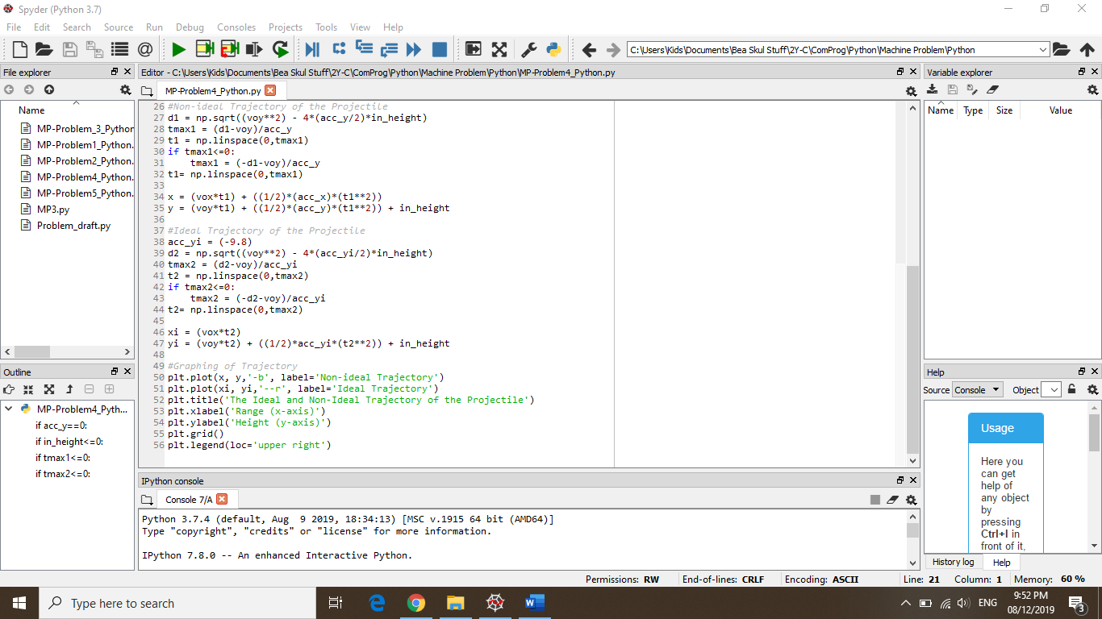

**TRIAL #1:**

* Inputs:
* Initial height (in m) = 100
* Magnitude of velocity (in m/s) = 100
* Angle (in degrees and w/ respect to the +x-axis) = 45
* x-component of the acceleration (in m/s2) = -1
* y-component of the acceleration (in m/s2) = -12

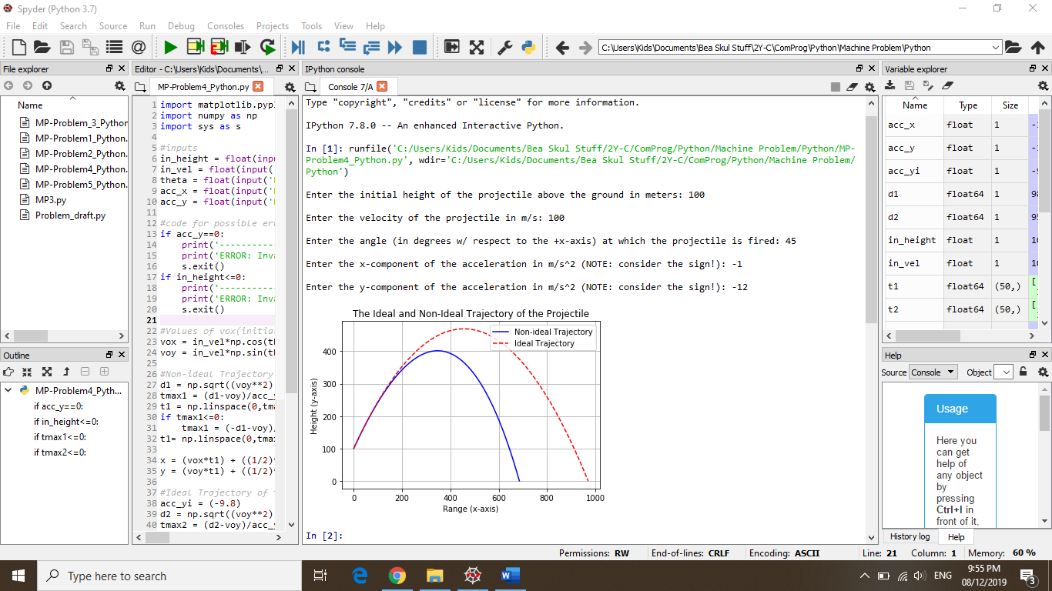

**TRIAL #2:**

* Inputs:
* Initial height (in m) = 50
* Magnitude of velocity (in m/s) = 30
* Angle (in degrees and w/ respect to the +x-axis) = 38
* x-component of the acceleration (in m/s2) = -12
* y-component of the acceleration (in m/s2) = -32

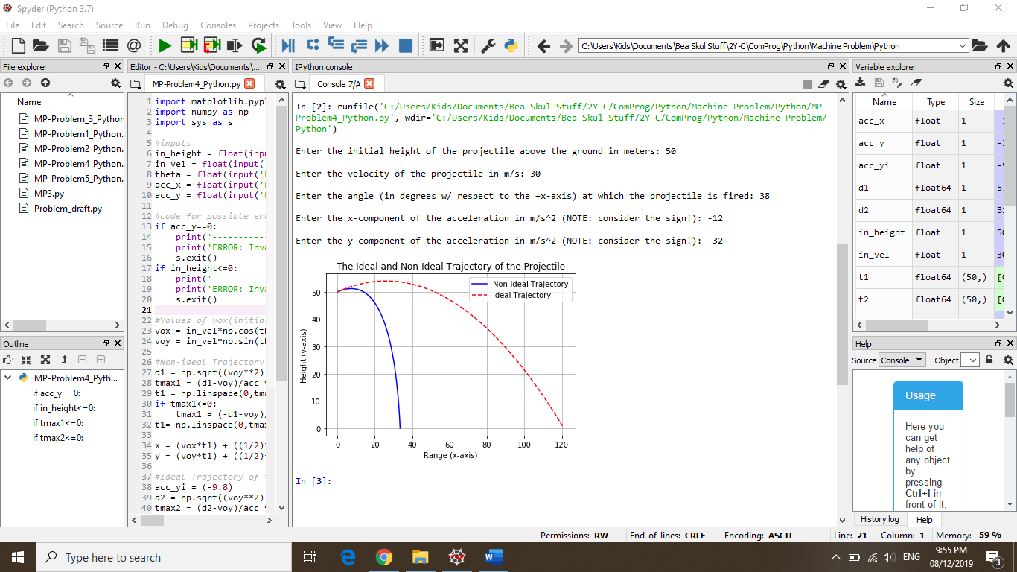

**TRIAL#3 (error):**

* Inputs:
* Initial height (in m) = 100
* Magnitude of velocity (in m/s) = 100
* Angle (in degrees and w/ respect to the +x-axis) = 45
* x-component of the acceleration (in m/s2) = -1
* y-component of the acceleration (in m/s2) = 0

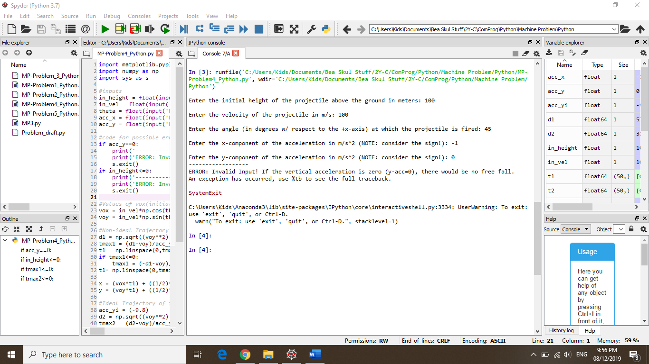

**TRIAL#4 (error):**

* Inputs:
* Initial height (in m) = 0
* Magnitude of velocity (in m/s) = 30
* Angle (in degrees and w/ respect to the +x-axis) = 38
* x-component of the acceleration (in m/s2) = -12
* y-component of the acceleration (in m/s2) = -32

